



**SM6P07NI Digital Media Project**

**20% Report**

**2019-20 Autumn**

**Student Name: Manish Yadav**

**London Met ID: 22067442**

**College ID: np01mm4a220121**

**External Supervisor: Aarsha Maharjan**

**Internal Supervisor Bijaya Raj Shakya**

**Assignment Due Date: Wednesday, May 7, 2025**

**Assignment Submission Date: Wednesday, May 7, 2025**

**Word Count: 3400**

*I confirm that I understand my coursework needs to be submitted online via Google Classroom under the relevant module page before the deadline in order for my assignment to be accepted and marked. I am fully aware that late submissions will be treated as non-submission and a mark of zero will be awarded.*

Abstract

This project centres around the development and execution of a high-quality television commercial for Jasmine Fitness Club and Spa, created as part of a final-year college module in digital media production. The documentation captures the full journey from concept to completion, showcasing the structured approach taken to deliver a visually compelling and brand-aligned advertisement. The pre-production phase included idea generation, scripting, casting, scheduling, and location planning to reflect Jasmine's premium image and holistic fitness philosophy. During production, live-action footage was captured with professional actors and a videographer, emphasizing the gym’s modern facilities, vibrant environment, and wellness-centred design. The post-production phase involved dynamic editing synced to music beats, scene matching for visual consistency, and light colour correction to enhance aesthetics. Despite challenges such as schedule delays and logistical constraints, the final TVC successfully encapsulates the brand’s luxurious yet grounded identity. This report further includes key technical breakdowns, creative decisions, third-party evaluations, and visual assets, highlighting the practical and strategic execution behind a market-ready commercial.

**Contents**

1 Introduction 1

1.1 Topic 1

1.2 Area of Research 1

2 Aims of Project 2

3 Target Audience 3

4 Product Research 4

5 Technologies Employed 5

6 Project Plan 6

7 Production Phases 7

8 Resources 8

9 User Testing & Findings 9

10 Conclusion 10

11 References 11

12 Bibliography 12

13 Appendix 13

**TABLE OF FIGURE**

Figure 1 Old Gantt chart 8

Figure 2 New gantt chart 9

Figure 3 Logbook 1 20

Figure 4 Logbook 2 21

Figure 5 Logbook 3 22

Figure 6 Logbook 4 23

Figure 7 Logbook 5 24

Figure 8 Logbook 6 25

Figure 9 Logbook 7 26

Figure 10 Logbook 8 27

Figure 11 Logbook 9 28

Figure 12 Logbook 10 29

Figure 13 Logbook 11 30

Figure 14 Project Managing 1 31

Figure 15 Project managing 2 32

Figure 16 Project Managing 3 33

# Introduction

## Topic

This project is about making a compelling commercial advertisement for Jasmine Fitness Club and Spa, a premium wellness brand known for its modern gym environment, state-of-the-art facilities, and aesthetic appeal. After conducting thorough research and engaging in multiple brainstorming sessions, the team developed a concept that aligned well with the brand’s identity and resonated with its broad target audience. The entire production followed a professional, industry-standard workflow—spanning pre-production, shooting, and post-production phases—resulting in a high-quality commercial.

Consultation with supervisors, the client, and advertising professionals helped maintain a sharp, professional edge throughout the project. A structured feedback loop allowed for continuous refinement at every stage. In addition to enhancing technical skills, the project also fostered growth in collaboration, time management, and creative development.

## Area of Research

The Jasmine Fitness Club and Spa commercial was developed through comprehensive research focused on understanding the brand’s identity, market position, and audience expectations. Initial research involved analysing the fitness and wellness industry in Nepal, identifying key trends such as the rising demand for luxury gym experiences and holistic wellness environments. Competitor analysis provided insight into how other premium fitness brands communicate their value, helping us shape a distinct visual and narrative direction for Jasmine.

Further research centred around the lifestyle and aspirations of Jasmine’s target audience—professionals, public figures, and families seeking modern, well-equipped, and aesthetically pleasing workout spaces. This informed the creative strategy, emphasizing themes of motivation, community, transformation, and self-care. Visual inspiration was drawn from high-end wellness campaigns and international fitness commercials, guiding our decisions in set design, lighting, and camera movement. The research stage was crucial in ensuring that the final concept not only met client expectations but also stood out in a competitive media landscape.

# Aims of Project

The aim of this project is to position Jasmine Fitness Club and Spa as a leading name in Nepal’s premium fitness and wellness industry through a visually captivating and emotionally engaging television commercial. The ad is designed to enhance brand visibility, communicate Jasmine’s modern, high-end environment, and attract a health-conscious, aspirational audience. By showcasing the club’s advanced facilities, elegant interior design, and inviting atmosphere, the commercial aims to appeal to professionals, influencers, and families looking for more than just a gym—a complete lifestyle upgrade.

At its core, the project seeks to highlight Jasmine’s commitment to luxury, community, and personal transformation. By blending dynamic visuals with uplifting energy and a polished, cinematic style, the commercial will not only increase brand awareness but also create a strong emotional connection with potential clients. Ultimately, the goal is to build lasting brand loyalty and elevate Jasmine as a symbol of modern fitness and wellness in Nepal.

# Target Audience

**Age Group:**  
The Jasmine Fitness Club & Spa commercial is primarily geared toward individuals aged 16 to 55—ranging from energetic teens just beginning their fitness journey to working adults balancing wellness with busy lifestyles, and older age groups focused on maintaining long-term health and vitality.

**Gender:**  
The advertisement adopts an inclusive approach by promoting a gender-neutral experience. All services and visuals reflect a wellness environment designed for everyone—regardless of gender identity—underlining Jasmine’s message: fitness and relaxation are universal needs.

**Socio-Economic Status & Profession:**  
The campaign speaks to individuals from middle to upper-middle income brackets who are health-aware and lifestyle-driven. This includes college students, working professionals in tech, media, business, and education, as well as homemakers and self-employed individuals seeking physical transformation and mental rejuvenation through premium fitness and spa services.

**Hobbies & Lifestyle:**  
This demographic is largely made up of people who care deeply about wellness, self-care, and personal progress. Whether it’s regular gym-goers, yoga lovers, wellness seekers, or individuals fond of spa therapies, their lifestyle often blends physical goals with mindfulness. Many of them follow health trends online, value clean aesthetics, and enjoy being part of like-minded fitness communities.

**Location & Market Strategy:**  
The commercial is focused on urban Nepal—especially Kathmandu and Lalitpur—where modern lifestyles and fitness trends are thriving. It follows a digital-first strategy optimized for Instagram, Tok-tok, Facebook, and YouTube, aiming to attract both local clients and international Nepali audiences who resonate with Jasmine’s values. For those abroad, Jasmine represents a slice of home—rooted in luxury, wellness, and Nepali community spirit.

# User Persona



**Name:** Aayush Karki  
**Age:** 28  
**Gender:** Male  
**Occupation:** IT Consultant at a multinational company  
**Monthly Income:** NPR 1,00,000 – 1,50,000  
**Location:** Bhaisepati, Lalitpur  
**Education:** Master’s Degree in Information Technology  
**Marital Status:** Unmarried  
**Transportation:** Owns a Royal Enfield Meteor 350  
**Living Situation:** Lives in a rented 1BHK studio apartment with modern amenities  
**Shopping Preference:** Spends on wellness, fitness gear, premium gym memberships, and high-quality lifestyle products

**Lifestyle & Behaviour**

Aayush works in a fast-paced corporate environment, often managing tight deadlines and tech projects. He is health-conscious and dedicates time to physical fitness despite his busy schedule, working out at least five times a week—early mornings or late evenings. He prefers gyms with a clean, premium ambiance, advanced equipment, and wellness-focused features like spas or sauna facilities.

He enjoys smart-casual fashion, invests in high-performance activewear, and prefers minimalist, stylish accessories. Aayush follows fitness influencers and wellness coaches on Instagram and YouTube, staying updated with the latest in body transformation tips and diet trends. On weekends, he enjoys riding out to scenic spots or relaxing with close friends. He values mental health as much as physical fitness and is drawn to places that offer a peaceful, high-standard environment for self-improvement.

**Needs & Goals**

* Wants a gym that not only provides great equipment but also aligns with his lifestyle and values—clean, disciplined, and elite.
* Seeks a fitness club that feels exclusive but welcoming, offering more than just machines—something with a wellness experience.
* Looks for fitness spaces that are Instagram-worthy but not overcrowded or chaotic.
* Aims to maintain a toned, healthy body to enhance confidence in both personal and professional life.

**Pain Points**

* Frustrated with conventional gyms that are either too basic or too commercial with little focus on quality ambiance.
* Finds it hard to get a gym that balances advanced facilities, professionalism, and peace.
* Dislikes crowded, noisy workout spaces with poorly maintained hygiene or equipment.
* Limited time to visit different gyms to compare services due to a packed work routine.

**Why Jasmine Fitness Club & Spa Appeals to Him**

Jasmine Fitness Club and Spa offers a serene, luxurious space equipped with modern fitness gear, spa facilities, and a professional environment. The brand reflects the values Aayush admires — a blend of physical fitness, inner wellness, and sophisticated style. The gym’s minimalist aesthetic, elite vibe, and dedication to a high standard of cleanliness and service perfectly match his expectations. It gives him a place to focus, unwind, and stay fit — all in one destination.

# Product Research

The Jasmine Fitness Club and Spa commercial drew creative inspiration from luxury wellness and fitness brands such as Equinox and Virgin Active, adopting a modern, aspirational tone that aligns with Jasmine’s identity. The visual approach emphasized sleek aesthetics, clean lighting setups, and dynamic movement to showcase the gym’s cutting-edge equipment, spacious interiors, and sophisticated atmosphere. Fluid camera tracking, wide-angle shots, and shallow depth of field were used to highlight the ambiance and energy of the space, while warm, natural colour grading enhanced the welcoming and premium feel.

The storytelling focused on real human experiences—moments of determination, transformation, and self-care—captured through expressive, action-based visuals rather than dialogue. A carefully curated soundtrack with uplifting tones and rhythmic momentum added emotional depth, reinforcing the themes of motivation and empowerment. The commercial followed a digital-first strategy, optimized for platforms like Instagram, Tok-tok, and YouTube, to resonate with a tech-savvy, urban audience. This approach aimed to position Jasmine not just as a gym, but as a lifestyle brand that promotes holistic well-being and a high standard of living.

# Technologies Employed

The Jasmine Fitness Club and Spa commercial was primarily developed using:  
**DaVinci Resolve**  
• Used extensively for editing, colour correction, and final delivery.  
• Colour grading helped maintain a clean, vibrant look to highlight the gym’s modern interiors.  
• Final logo animation and motion transitions were completed in **Adobe After Effects**, while the full timeline and rendering process were managed in DaVinci Resolve for workflow efficiency.

**Cinematic Techniques**  
• Smooth camera movements using gimbals and sliders were employed to give a dynamic and immersive feel.  
• Lighting was kept soft and natural, enhancing the premium, welcoming vibe of the gym environment.

**Digital Optimization**  
• Delivered in multiple aspect ratios (16:9, 1:1, and 9:16) for maximum engagement across platforms like Instagram, Tok-tok, and YouTube.  
• The post-production workflow was optimized within DaVinci Resolve, allowing for fast edits and high-quality exports tailored for both web and social media release.

# Project Plan

**Revised Production Timeline and Adjustments**

**Initial Plan vs Final Execution**

**Reason for Delay:**

The scheduled production of the Jasmine Fitness Club & Spa commercial was delayed due to two unforeseen circumstances. Firstly, the lead actress was selected to represent Nepal in the Miss World competition held in China, requiring her to travel abroad during the planned February–March shoot. This prestigious opportunity made her temporarily unavailable, resulting in an unavoidable delay of around 8–10 days. Secondly, a two-day national protest further disrupted the production timeline, affecting travel, access to locations, and overall safety for cast and crew. These combined factors required the team to reschedule and adjust the production calendar, while also making the most of the additional time for refining the project’s creative and logistical aspects.

|  |  |  |  |
| --- | --- | --- | --- |
| **Phase** | **Old timeline** | **New Timeline** | **Reason** |
| Production | Feb-march | Early April | Model unavailability |
| **Postproduction** | April-May | Early | Compressed scheduled |

**Comparison between old Gantt chart and New Gantt chart**

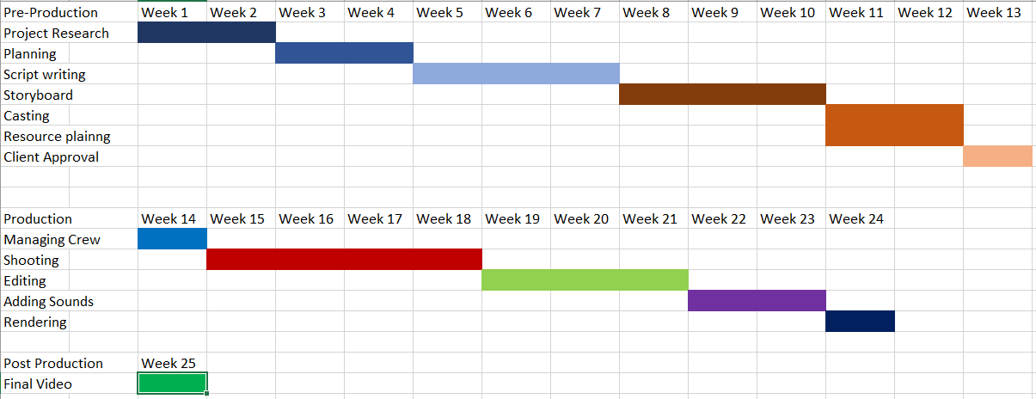

Figure 1 Old Gantt chart

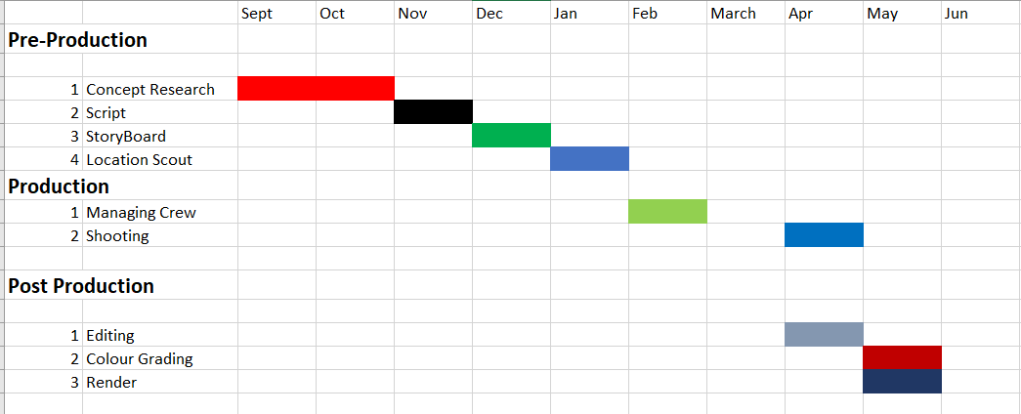

Figure 2 New Gantt chart

# Production Phases

**Stages of Production (Summarized)**

**Pre-Production Phase**  
**Phase 1:** Laying the foundation for the concept, visuals, and logistics  
**Key Steps:**  
• **Concept Development:** Crafted a vision of luxury, wellness, and transformation inspired by high-end fitness centres, focusing on clean, modern visuals.  
• **Script & Storyboard:** Designed to convey the journey of personal growth and empowerment through dynamic visuals, emphasizing action over dialogue.  
• **Casting:** Chose a diverse pair of actors to embody the strength, grace, and motivation that Jasmine represents, ensuring they connect with a wide audience.  
• **Location Selection:** The commercial was shot entirely within the club, allowing for an authentic portrayal of the gym’s state-of-the-art facilities and inviting atmosphere.

**Production Phase**  
**Goal:** Capturing the essence of the brand through impactful visuals  
**Key Steps:**  
• **Call Sheet:** Organized all crew members, times, and equipment to ensure a smooth shoot, with clear roles and responsibilities for everyone.  
• **Filming:**  
Focused on the gym's vibrant energy through steady shots that highlighted both the space and the individuals working out.  
Utilized lighting setups to create an inviting, sophisticated atmosphere, while employing versatile camera movements to showcase the flow of activity.  
• **Set Dynamics:** Allowed flexibility on set for spontaneous adjustments, capturing real moments of movement and energy.  
• **Collaboration:** Worked closely with the director, videographers, and crew to ensure that the vision was being brought to life seamlessly.

**Post-Production Phase**  
**Task**: Refining raw footage into a polished final product  
**Key Steps:**  
• **Editing in DaVinci Resolve:**  
Edited footage with an emphasis on smooth transitions and pacing to maintain a rhythmic flow. The goal was to create an engaging experience that reflected the energy of the club.  
• **Sound Design:**  
Layered motivational music and authentic foley sounds, such as gym equipment clanking and footsteps, to immerse viewers in the environment.  
• **Colour Grading:**  
Applied a warm, inviting colour palette to emphasize the modern yet welcoming aesthetic of the gym. Enhanced contrast to bring out the richness of the visuals and highlight the luxurious feel of the brand.  
• **Final Export:**  
Prepared different formats (16:9, 1:1, 9:16) to ensure compatibility across all digital platforms, optimizing the content for Instagram, Tok-tok, and YouTube.

# Resources

Tools for Producing the Jasmine Fitness Club & Spa Commercial: Hardware & Software

**Production Hardware (Filming Gear)  
Main Equipment (As Originally Planned):**  
• **SONY FX3**: A 4K Cinema Line Camera used for capturing high-quality, natural footage that highlights the luxurious atmosphere of the gym.  
• **Stabilization**: Gimbal for smooth tracking shots that convey the energy of the fitness center.  
• **Static Shots**: Tripod setup used for steady shots of the gym’s interior, ensuring clear and sharp visuals.  
• **Lighting**: LED tube light is used as natural lightning.

**Additional Gear (On-the-Go):**  
• **Batteries and Storage**: Extra SD cards and power backups were essential to support long filming days and avoid downtime during the shoot.

**Post-Production Hardware**  
**Main Tool:**  
**• Laptop**: The Asus TUF Gaming A15, featuring a powerful processor and GPU, was used for editing and rendering tasks. It efficiently handled the post-production workload, although rendering times for high-res footage were initially slow, prompting the use of proxies to maintain a smooth workflow.

**Challenges and Solutions:**  
• Rendering Speed: Given the high-quality footage, rendering times were a concern, but proxies allowed for faster editing and rendering, ensuring the project stayed on schedule.

**Software Tools**  
**Core Software (As Planned):**  
• **Editing & Color Grading**: DaVinci Resolve was used for editing, timeline assembly, and color correction, ensuring that the visuals matched the luxurious and modern aesthetic of Jasmine Fitness Club & Spa.  
• **Motion Graphics**: Adobe After Effects was employed for the creation of the logo animation.

**Research & Testing Tools**  
**Pre-Production:**  
• **Mood Board Creation:** Pinterest and Adobe Spark were used to create a mood board that captured the modern, luxurious vibe of the gym and fitness lifestyle, drawing inspiration from high-end fitness brands.  
• **Location Scouting:** Google Maps and Street View were used initially to explore potential gym locations, followed by in-person visits to finalize the ideal setting for the shoot.

**On-Set Testing:**  
• **Exposure Testing:** A light meter was employed to balance exposure during the shoot, ensuring consistent and flattering lighting in every shot.  
• **Camera Testing:** Test shots were taken to evaluate how the gym’s interior and the models appeared under different lighting conditions, ensuring all footage was captured with clarity and depth.

**Post-Production Testing:**  
• **Export Tests:** Multiple export versions (H.264, H.265) were created and tested on social media platforms (Instagram, Tok-tok, YouTube) to ensure the commercial played seamlessly on various devices and maintained its quality across resolutions.

# User Testing & Findings

After completing the final cut, the commercial was tested for compatibility across various devices and platforms to ensure seamless playback and optimal visual quality across different screen sizes and resolutions. The primary goal was to maintain visual consistency and aspect ratio integrity, ensuring smooth performance across all devices.

**Device and Display Testing**

**A. Smartphones**  
*Screen Sizes:* 6” to 6.7” (common flagship models)  
*Aspect Ratios Tested:*  
• 16:9 (Standard aspect ratio for older models, e.g., Samsung, LG)  
• 18:9 (Taller displays, e.g., Google Pixel)  
• 20:9 (Ultra-tall displays, e.g., Samsung Galaxy)

**Findings:**  
• No cropping or letterboxing issues were observed. The adaptive scaling ensured a clean display across all models.  
• Despite smaller screens, the text and logo clarity remained intact and easy to read.

**B. Tablets**  
*Screen Sizes:* 7” (e.g., Amazon Fire) to 12.9” (e.g., iPad Pro)  
*Aspect Ratios Tested:*  
• 4:3 (older iPads)  
• 16:10 (e.g., Samsung Galaxy Tab)

**Findings:**  
• Minimal letterboxing was seen on 4:3 aspect ratio devices, but no content was missing.  
• Colors remained vibrant on high-resolution screens, enhancing the overall visual appeal.

**C. Laptops & Desktops**  
*Resolutions Tested:*  
• Full HD (1920 x 1080) – Standard for most monitors  
• QHD (2560 x 1440) – High-end displays  
• 21:9 Ultrawide (3440 x 1440) – Cinematic experience

**Findings:**  
• No distortion or visual issues on ultrawide displays.  
• Playback in 4K on high-end systems was smooth and clear, particularly on systems with GPU performance (e.g., RTX 3060).

**D. Smart TVs**  
*Resolutions Tested:*  
• 4K UHD (3840 x 2160) – Smart TVs (e.g., Samsung, LG)  
• 1080p – Older LED/LCD TVs

**Findings:**  
• On 4K-compatible TVs, the textures of the fitness equipment were enhanced, with better contrast and detail.  
• Streaming on YouTube and other OTT platforms had no buffering issues even on slower Wi-Fi connections.

**Encoding & Performance Tests:**  
• H.264 and H.265 (HEVC) formats were used, achieving smaller file sizes without compromising quality, ensuring fast load times and minimal buffering.

**User Feedback & Iterations**

A focus group of 10 individuals was tasked with assessing the advertisement. Here’s what they had to say:

**Visual Appeal:**  
• 9/10 respondents praised the minimalist style and the stunning product shots that conveyed the gym’s luxurious atmosphere.  
• One participant suggested brightening the lighting in the café scene to enhance the mood.

**Brand Recall:**  
• 100% of participants could recall Jasmine Fitness Club and Spa immediately after viewing the logo animation.

**Loading Times:**  
• The advertisement performed flawlessly on YouTube with no buffering on both 4G and Wi-Fi connections.

**Post-Testing Adjustments:**  
• Increased the brightness of the midtones in the café scene to ensure better visibility without losing the atmosphere.  
• Shortened the logo animation by 0.5 seconds to create a sharper and more immediate impact.

# Conclusion

The production of the Jasmine Fitness Club & Spa commercial has been a highly rewarding and collaborative process. Through careful planning, creative execution, and the use of industry-standard tools and techniques, we were able to craft a visually captivating and emotionally resonant advertisement. By focusing on modern aesthetics, high-end production quality, and a clear narrative that aligns with the brand's luxurious and inclusive image, we successfully showcased the club’s premium facilities, vibrant atmosphere, and welcoming environment.

The integration of advanced equipment, such as the SONY FX3 and Asus TUFGaming A15 laptop, coupled with professional editing and post-production software like DaVinci Resolve and Adobe After Effects, allowed us to elevate the commercial’s quality to meet the expectations of the target audience. Furthermore, the digital-first strategy ensured that the content was optimized for various social media platforms, guaranteeing a wide reach and engagement with potential clients.

Ultimately, the Jasmine Fitness Club & Spa commercial not only highlights the brand’s core values of luxury, wellness, and community but also builds a strong emotional connection with viewers. This project has not only honed our technical and creative skills but also reaffirmed the importance of meticulous planning and testing in delivering a product that resonates with audiences while maintaining the integrity of the brand’s identity.

# Appendix

**Survey Result**

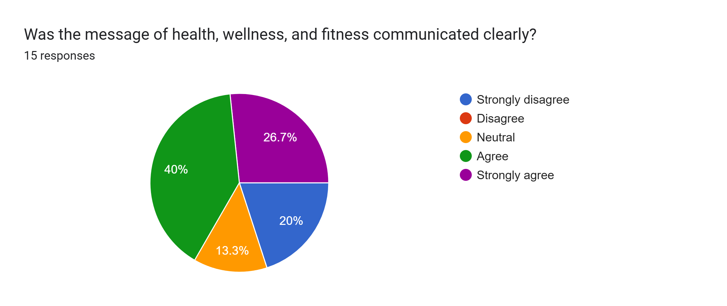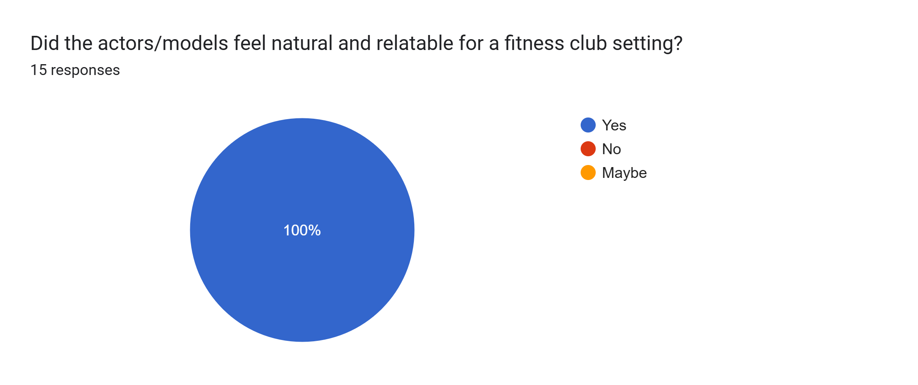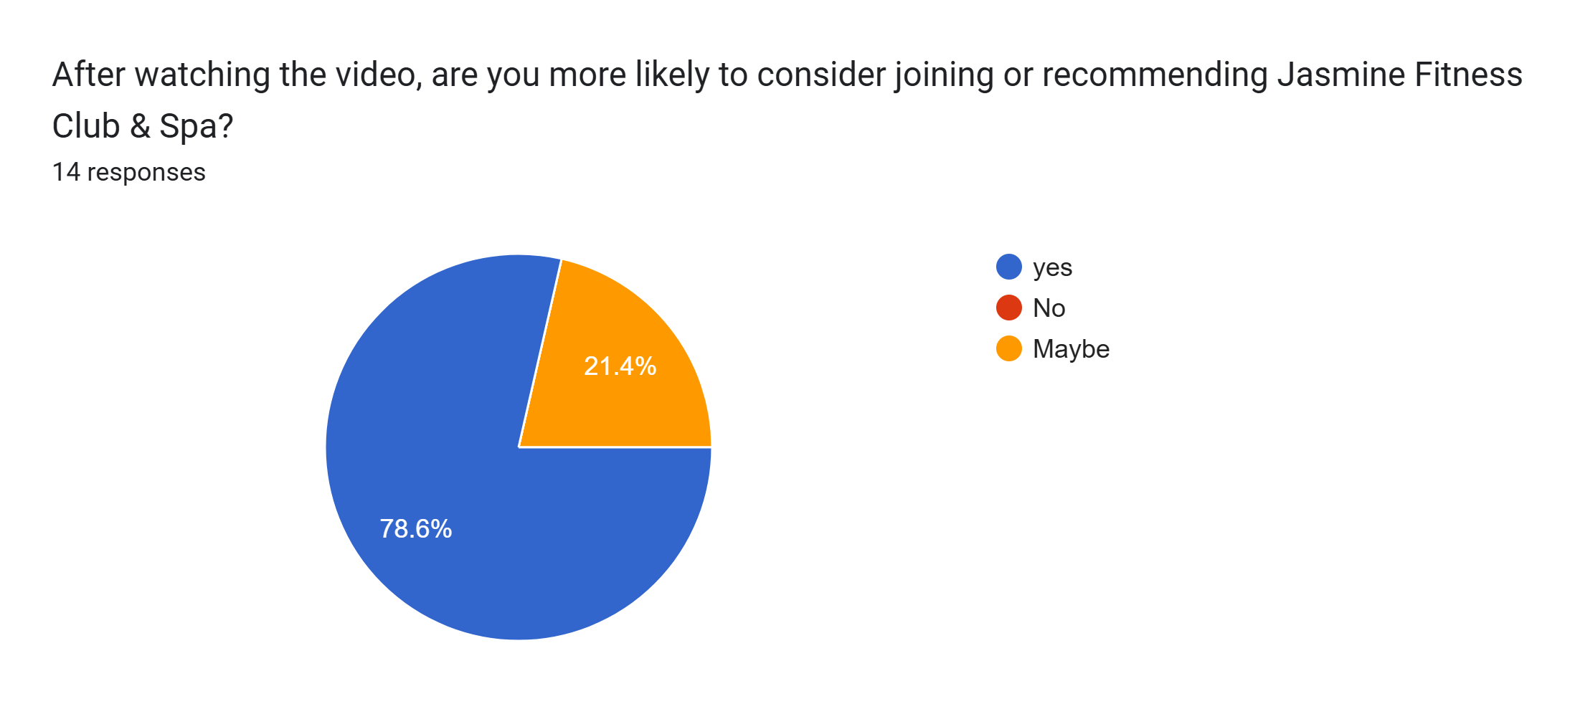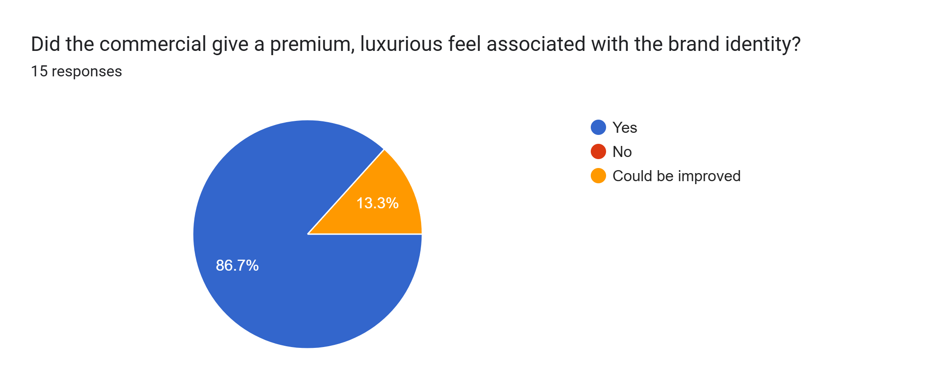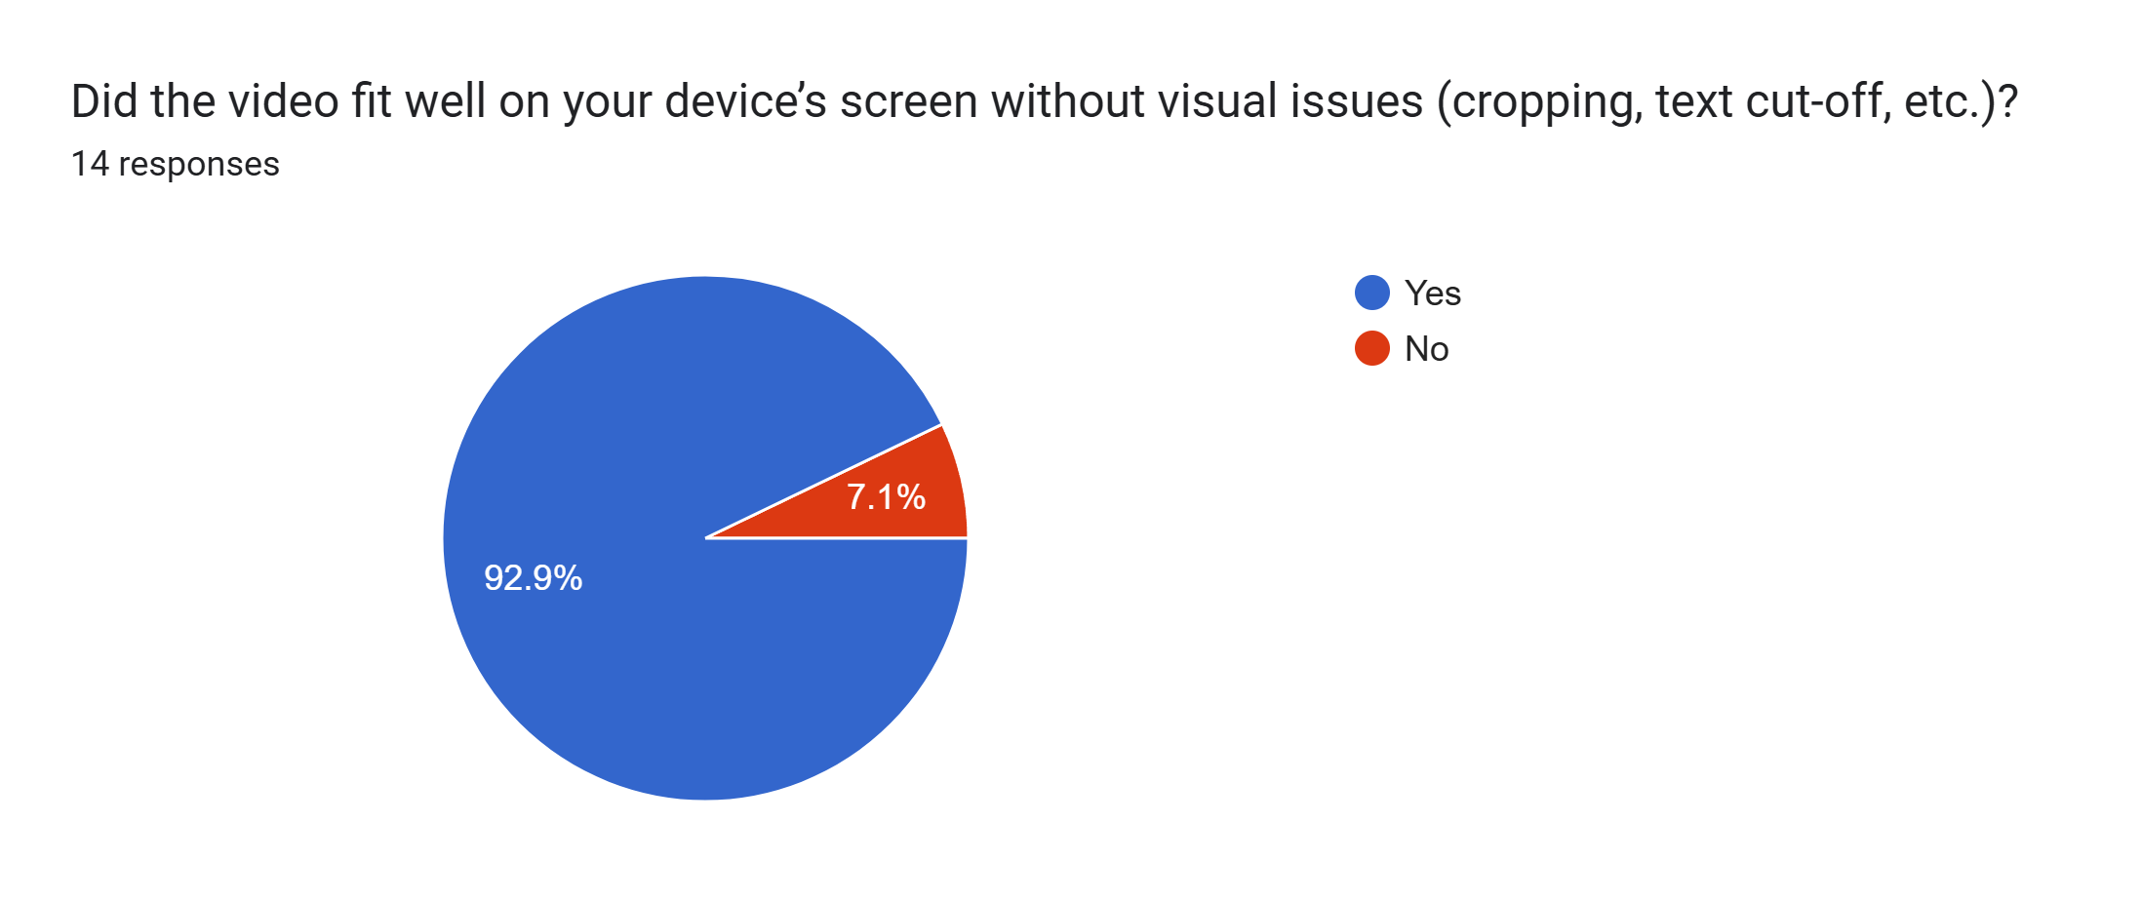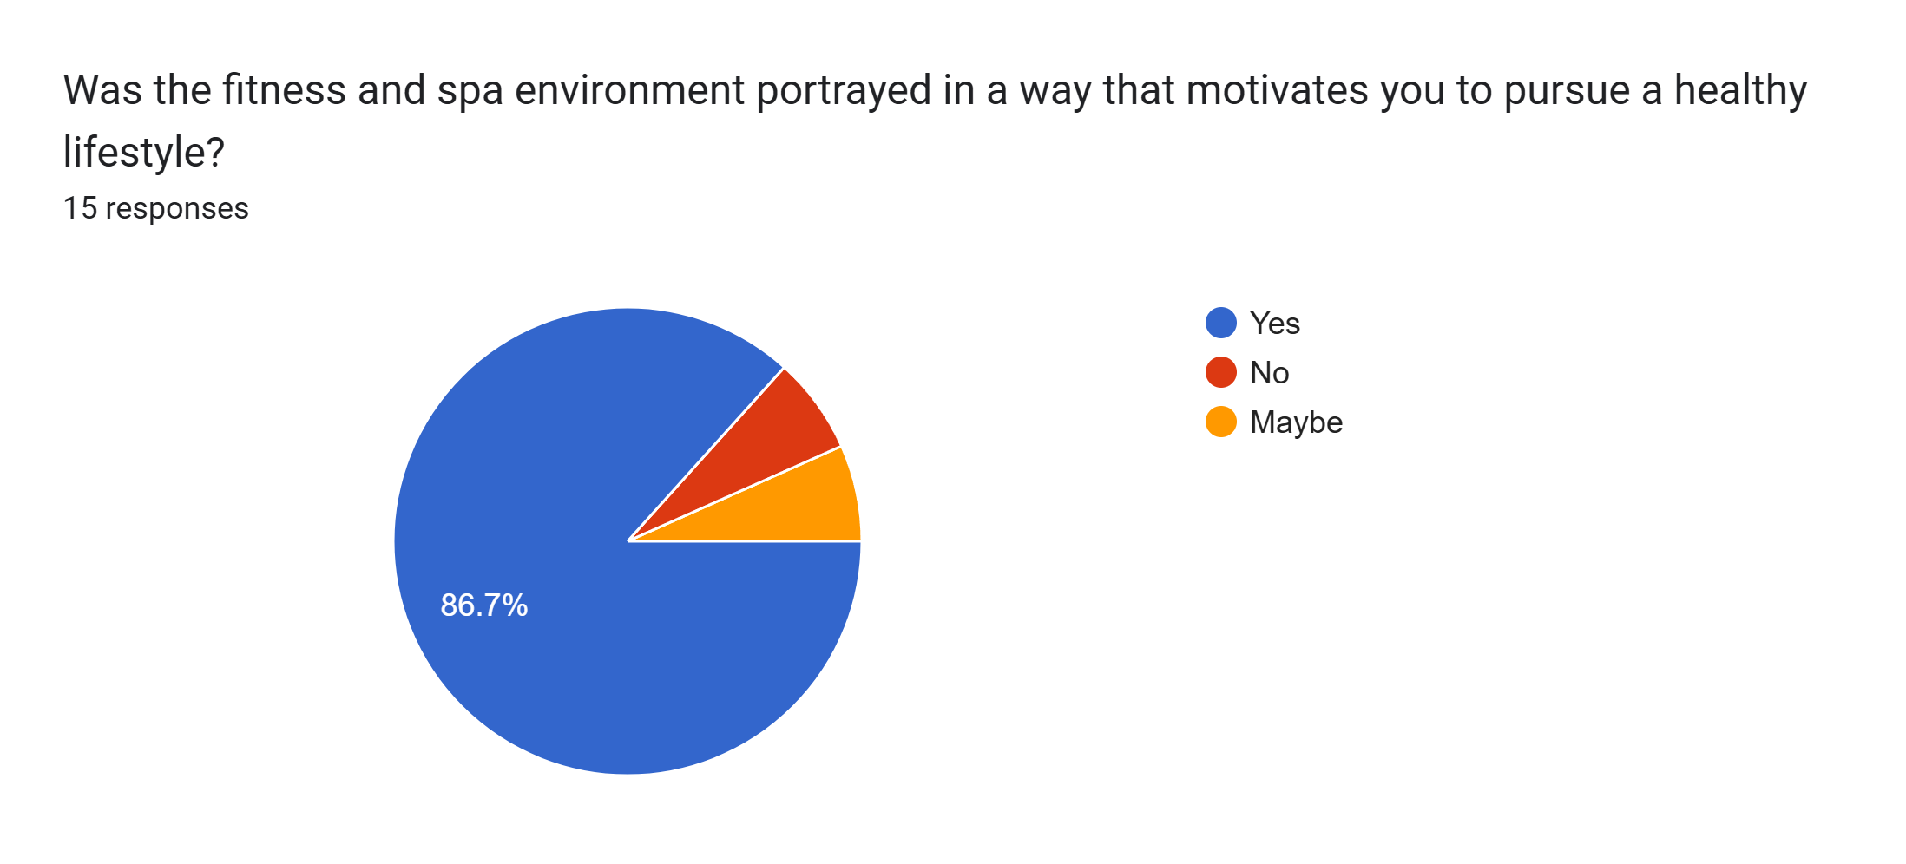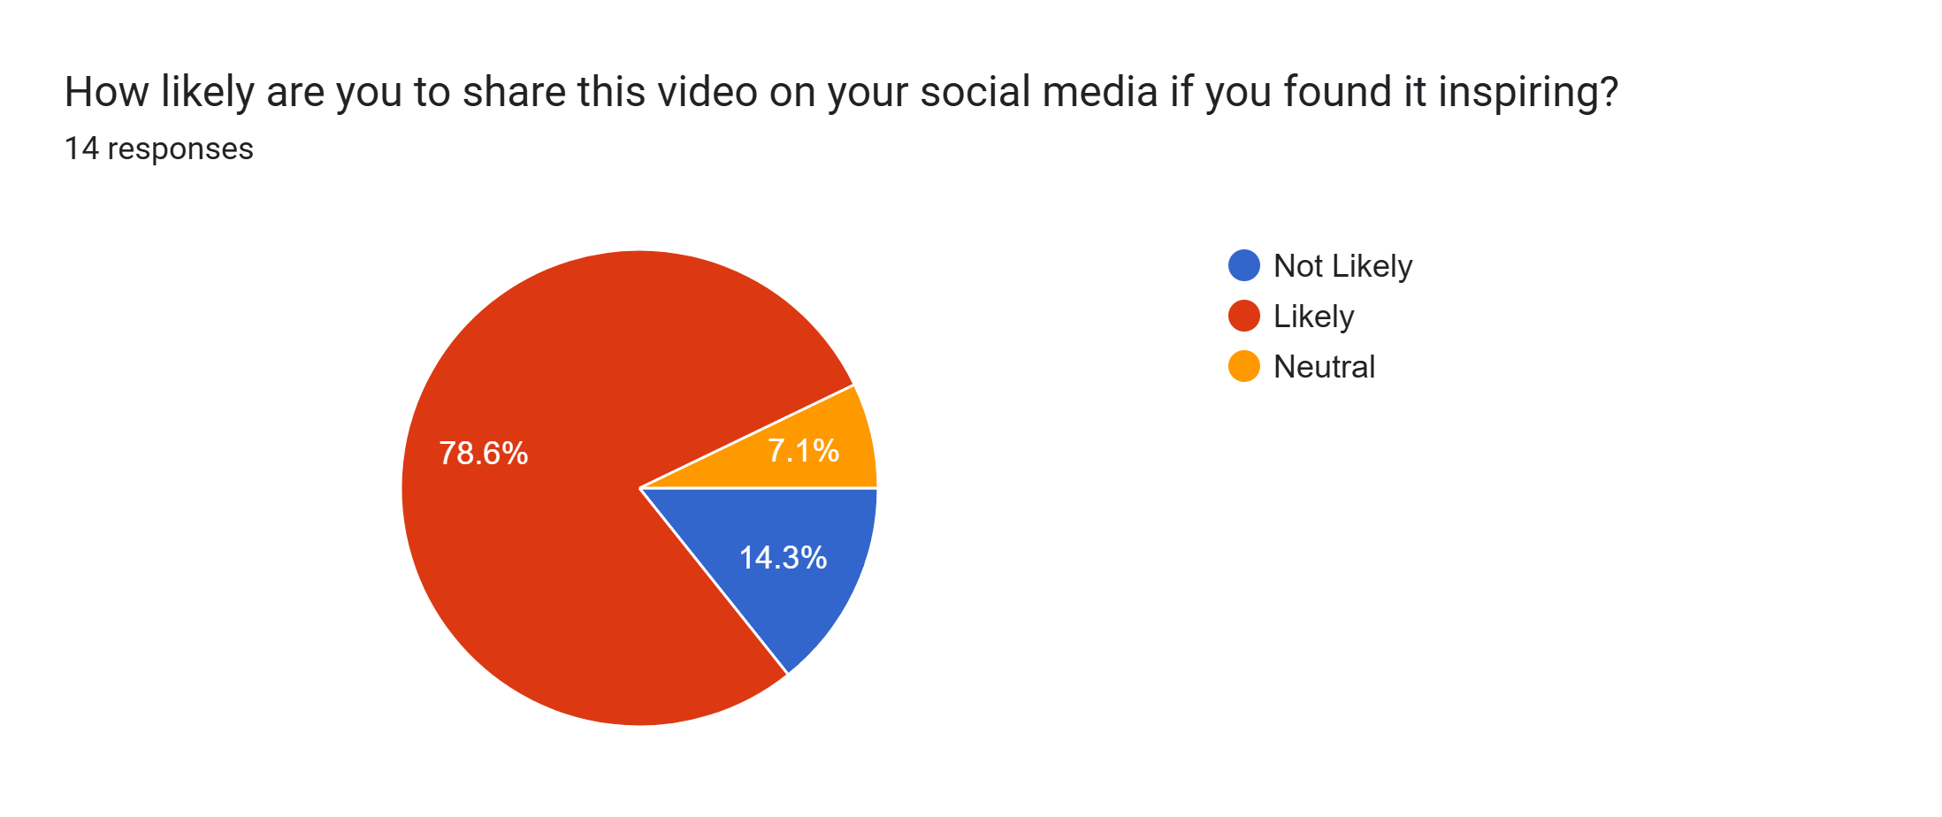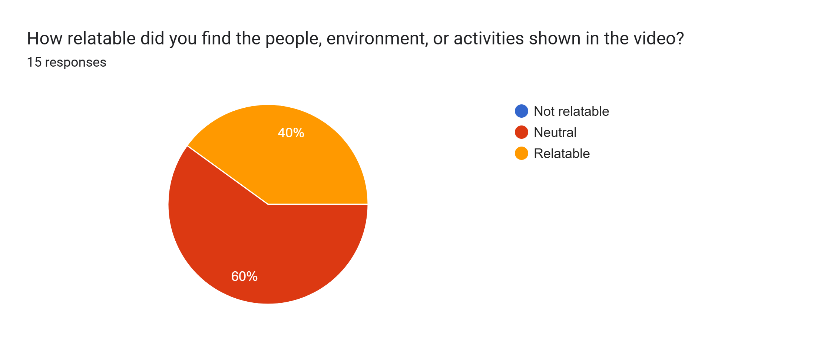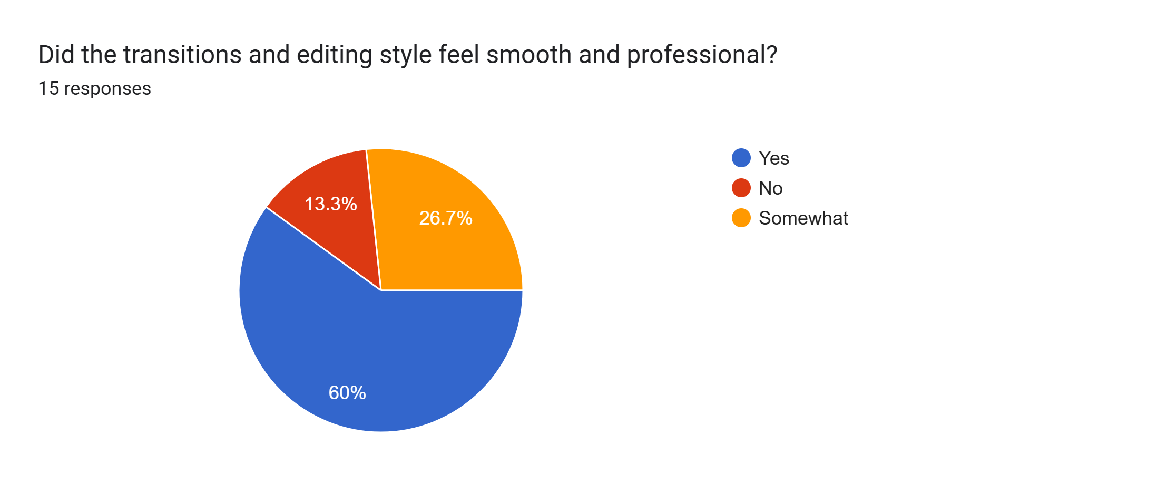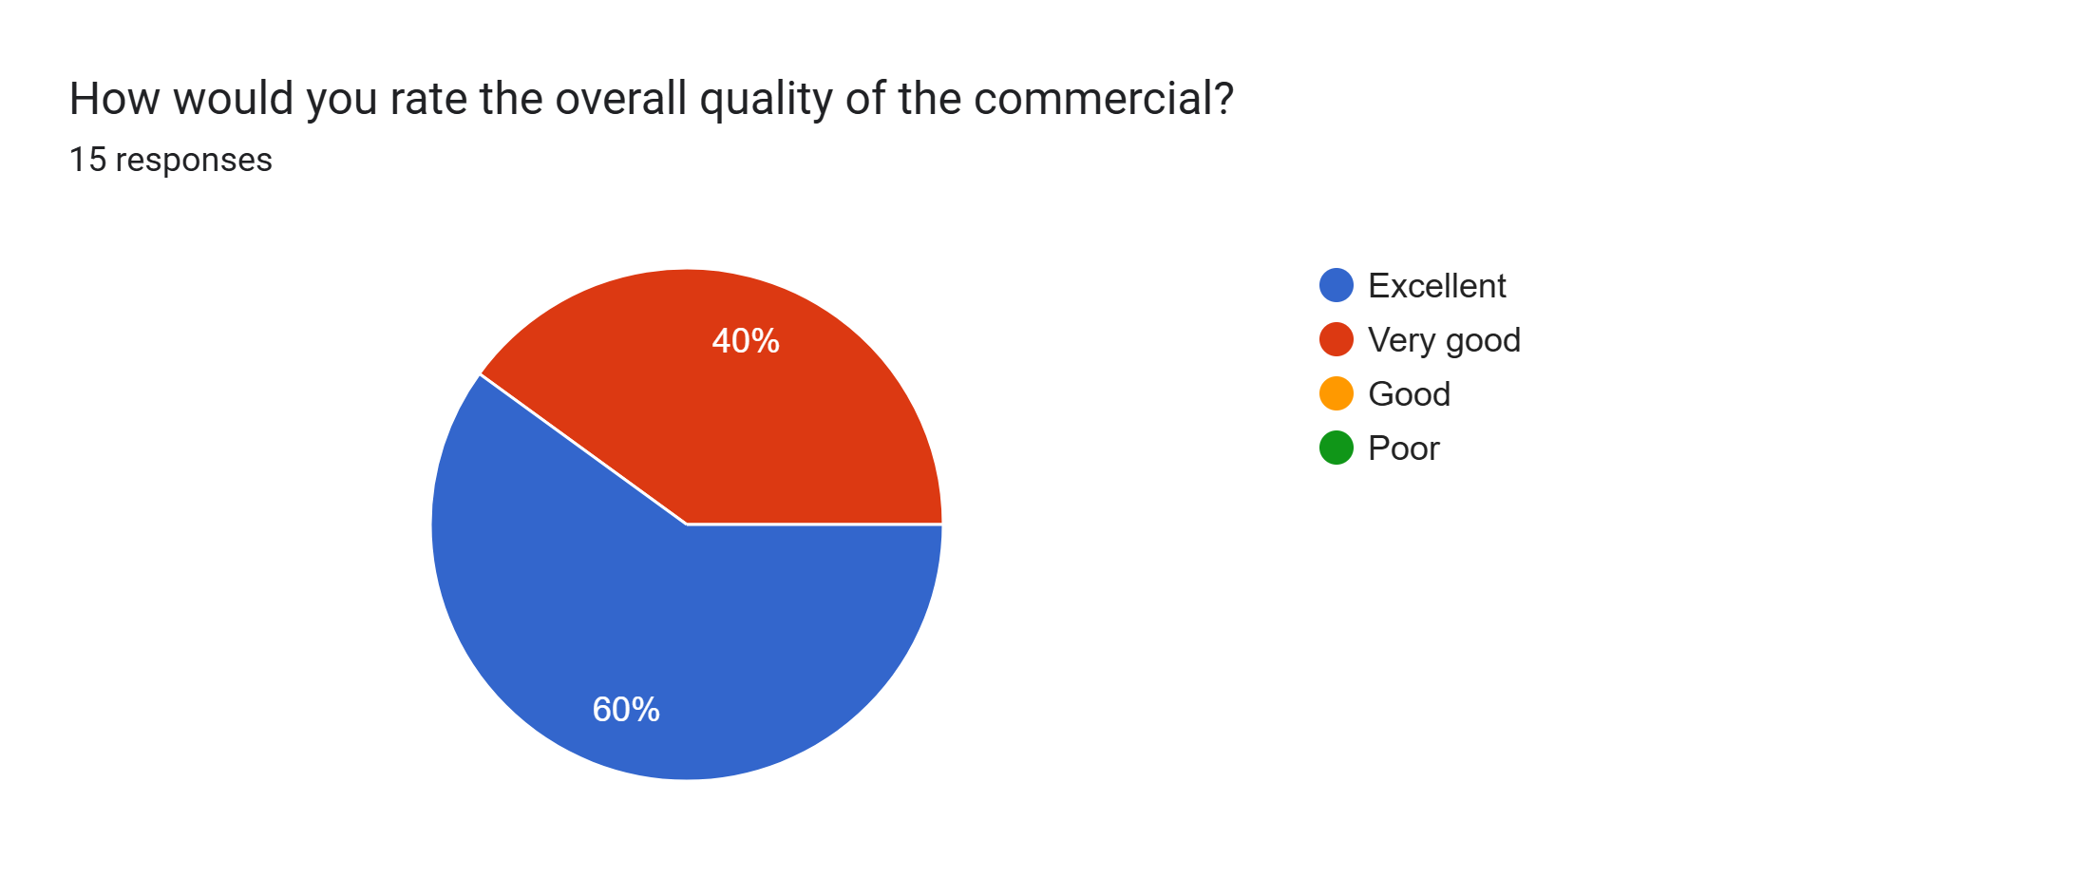

**Feedback**

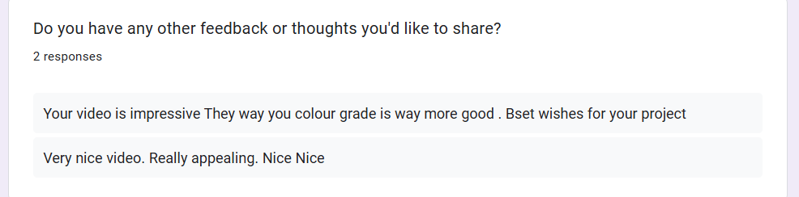

Survey From Link: <https://docs.google.com/forms/d/e/1FAIpQLSe9ZLZxabkyO6HHT4t_qeDyffCxwHBqMW5ymc2xQuCivyBTgA/viewform?usp=header>

**Weekly Log-Sheet**

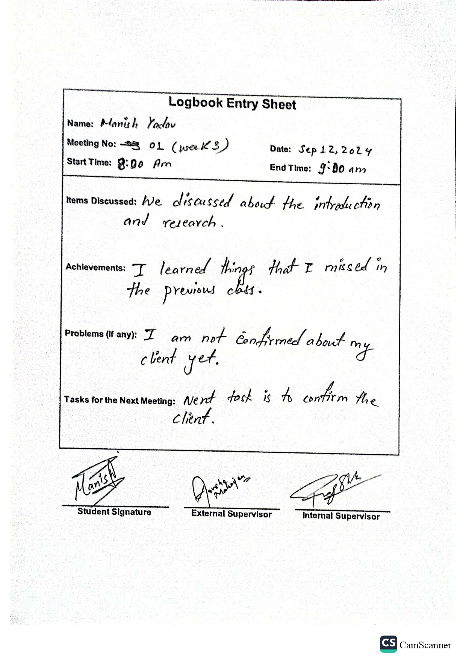

Figure 3 Logbook 1

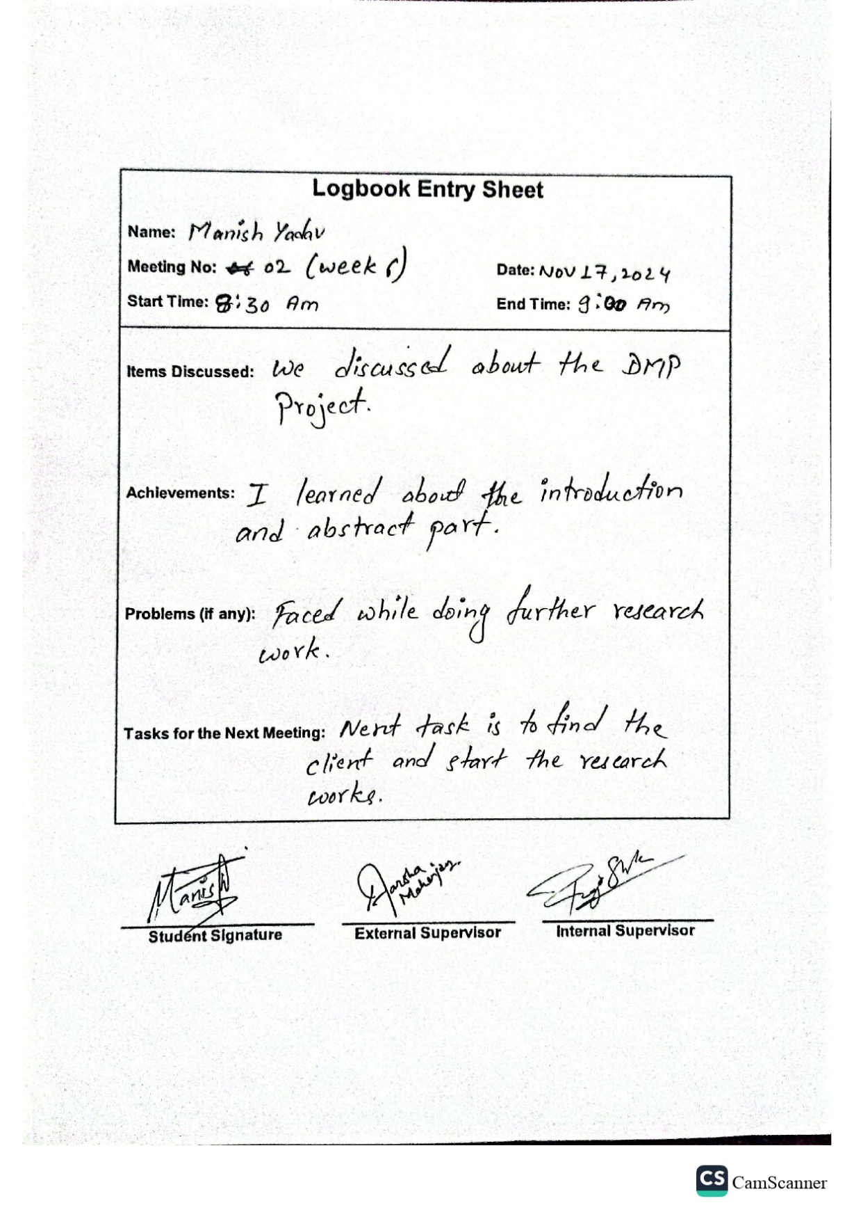

Figure 4 Logbook 2

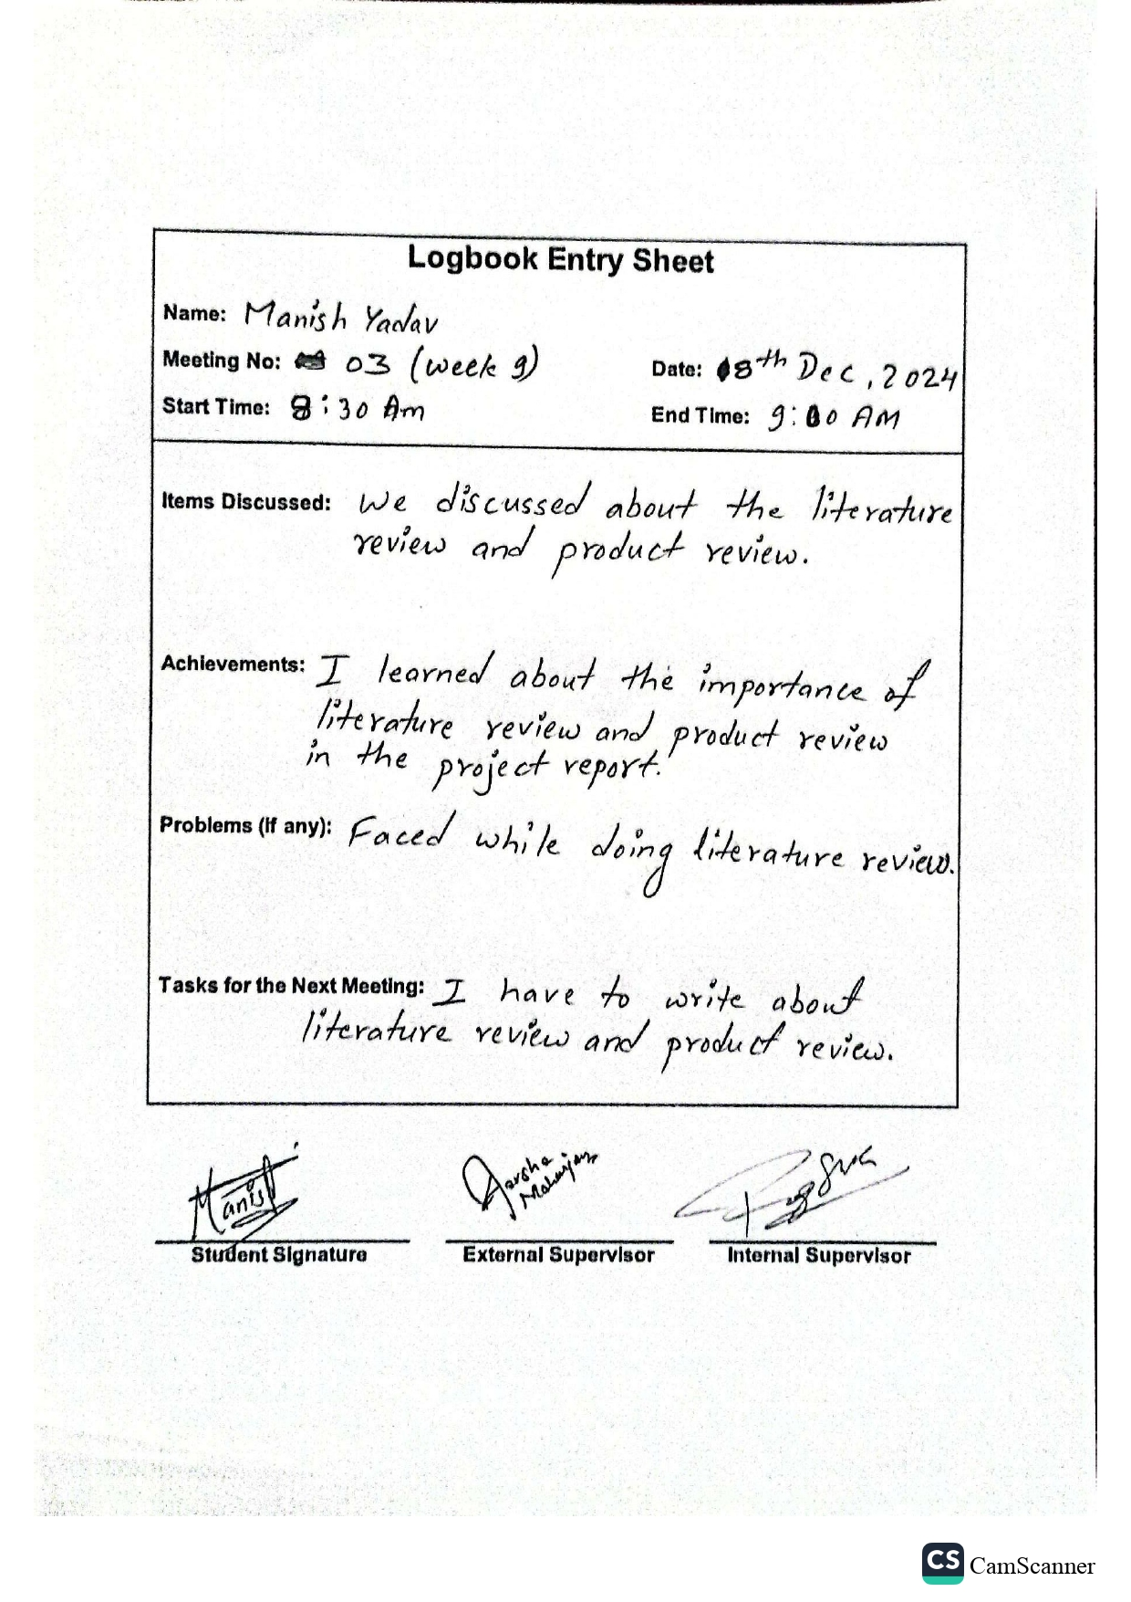

Figure 5 Logbook 3

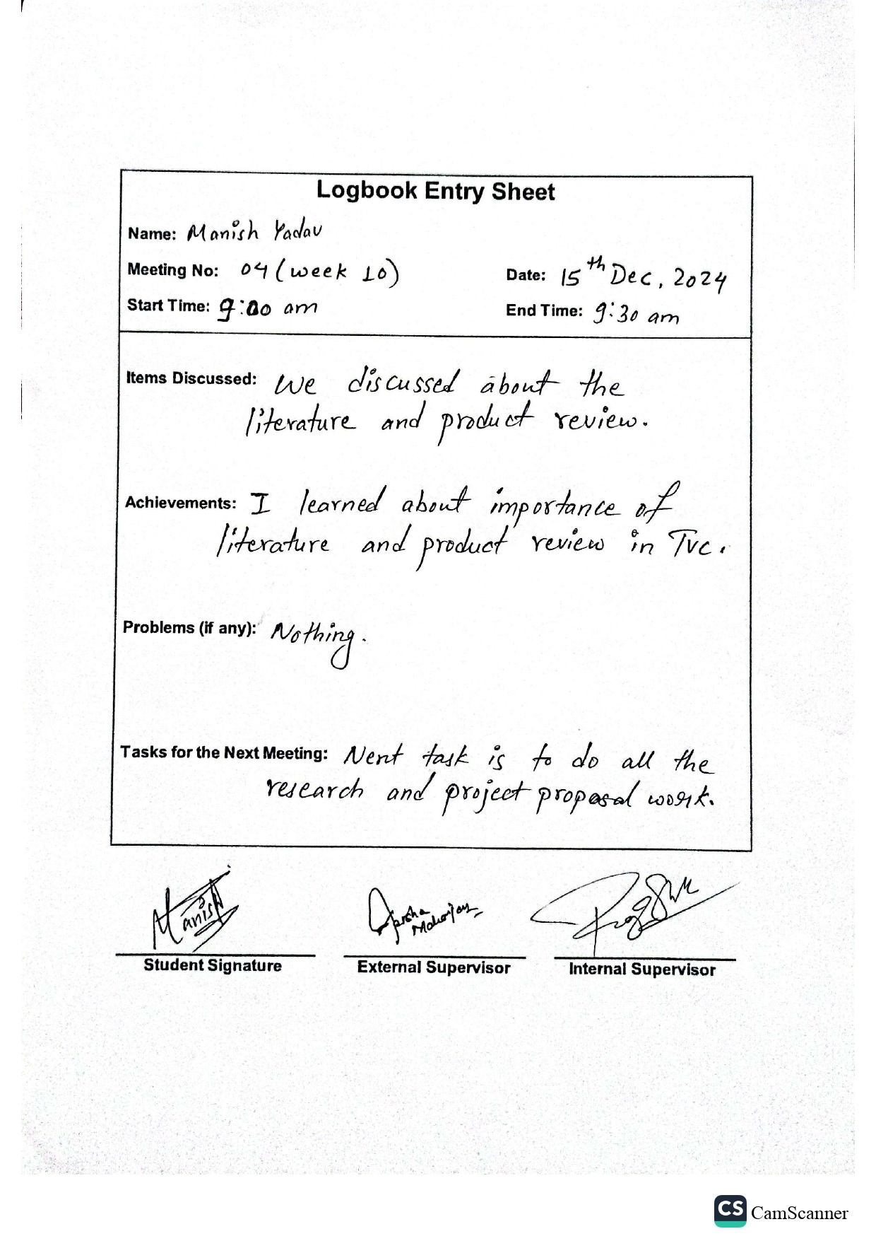

Figure 6 Logbook 4

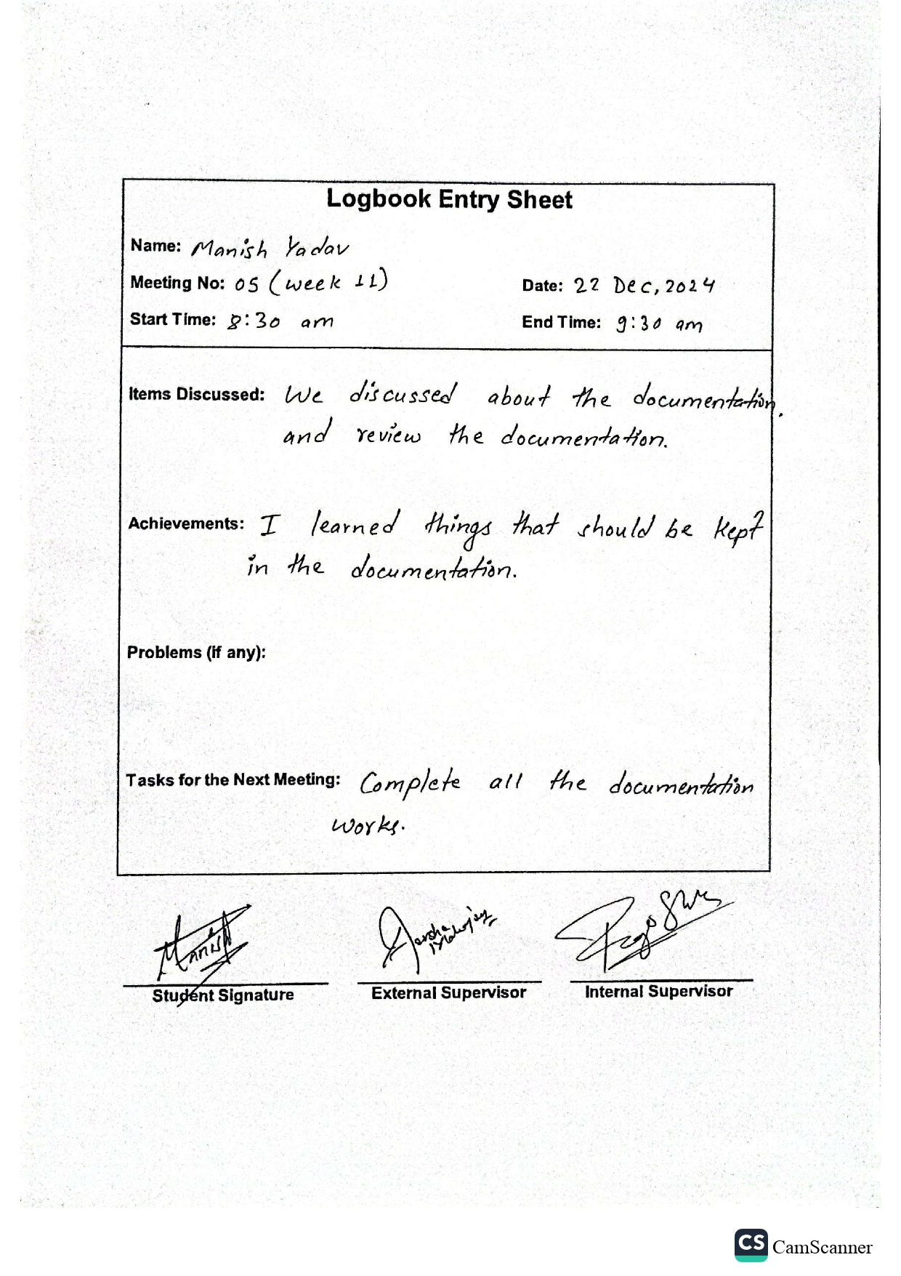

Figure 7 Logbook 5

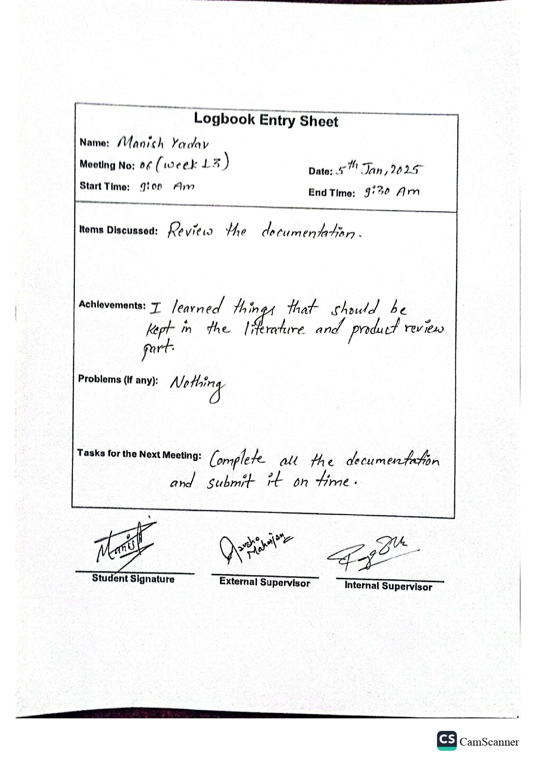

Figure 8 Logbook 6

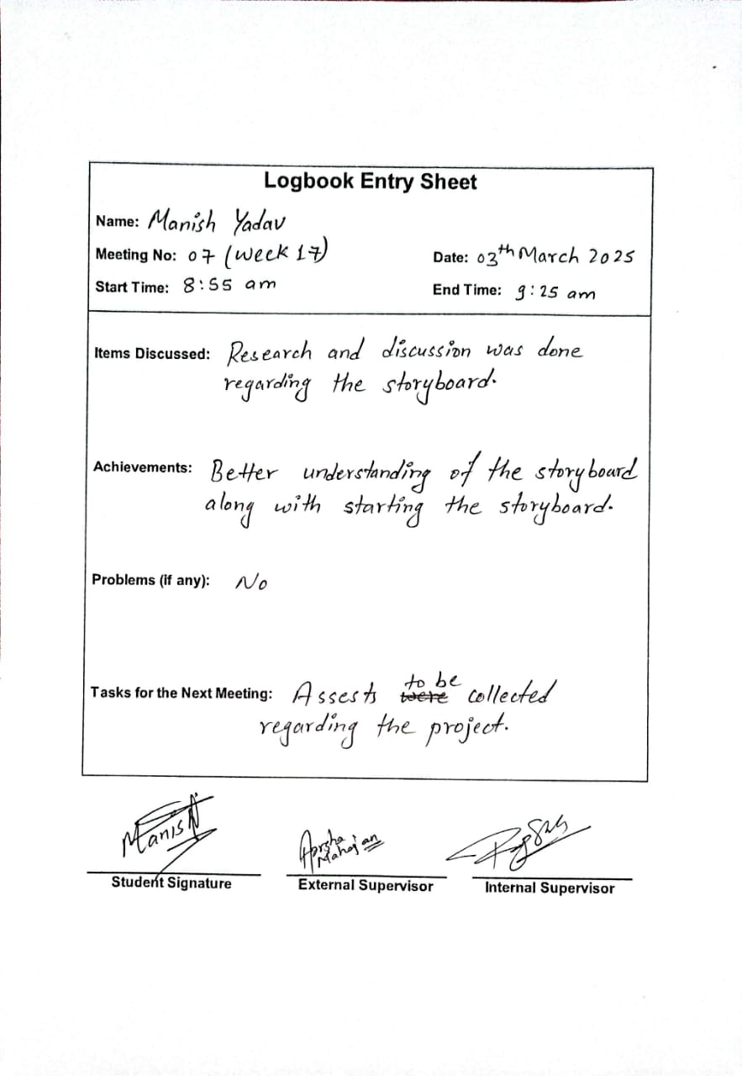

Figure 9 Logbook 7

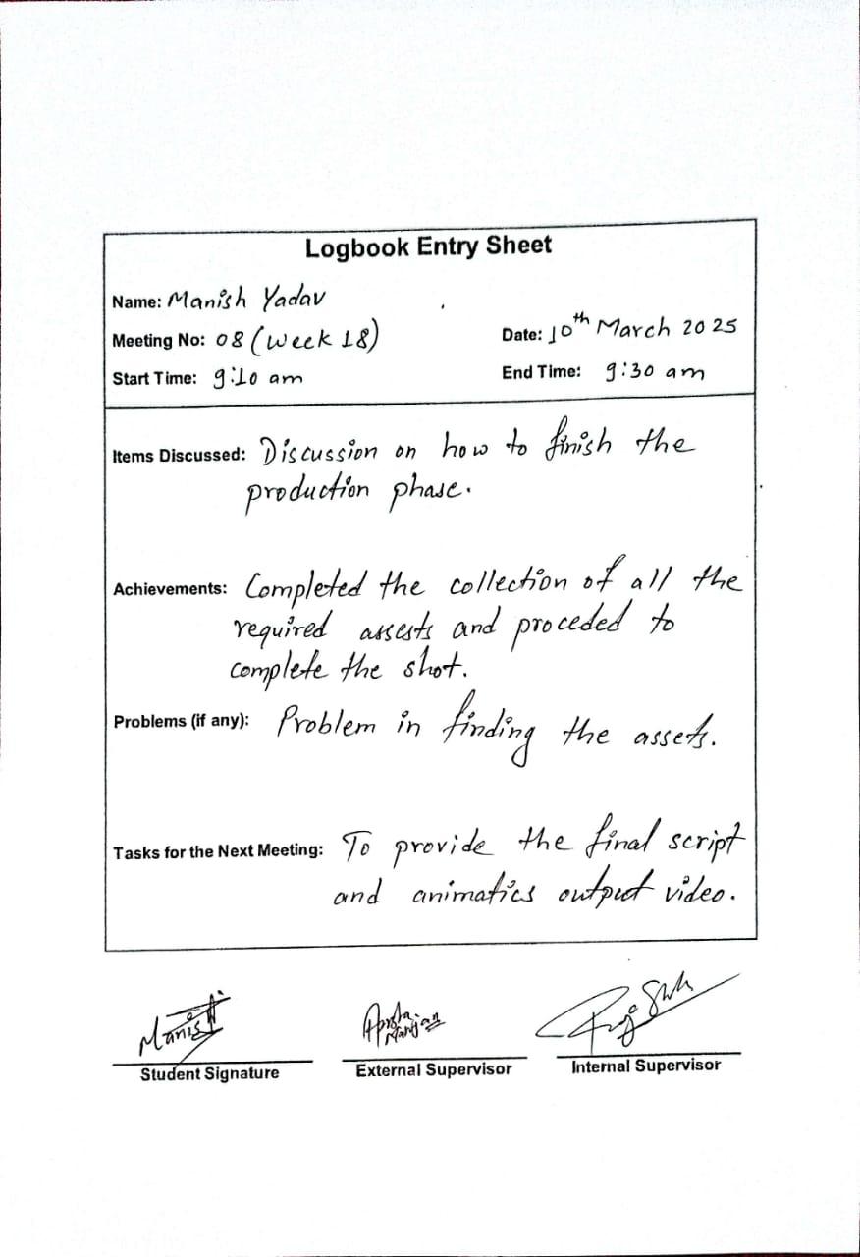

Figure 10 Logbook 8

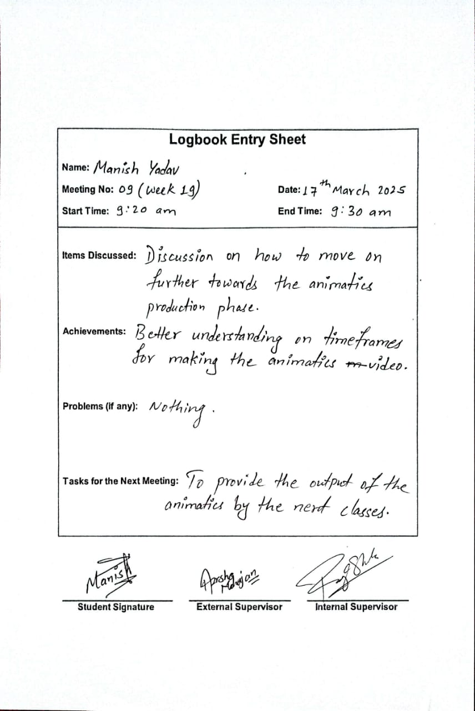

Figure 11 Logbook 9

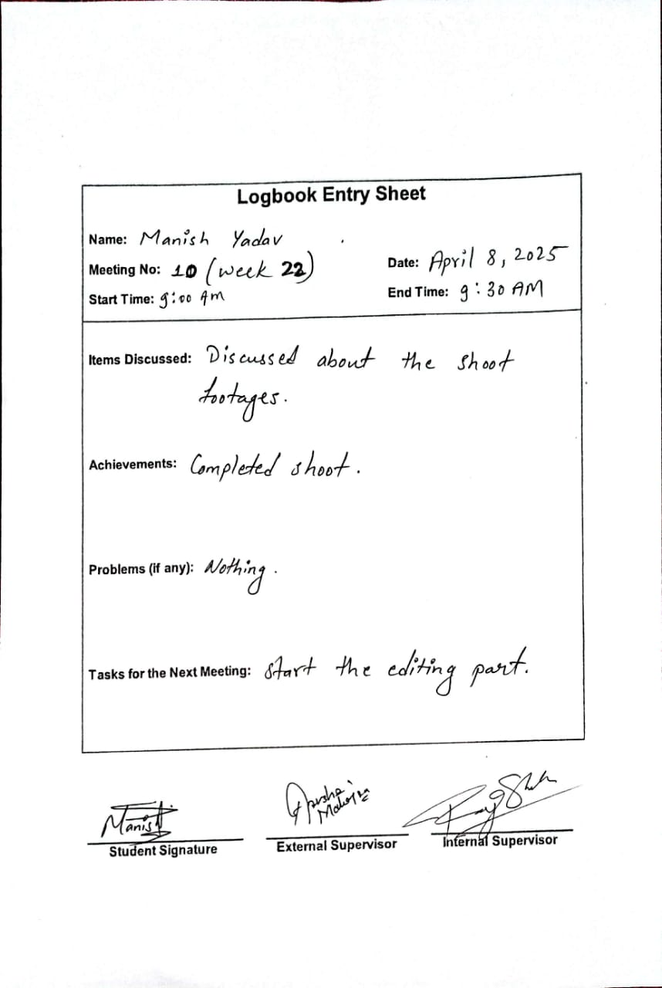

Figure 12 Logbook 10

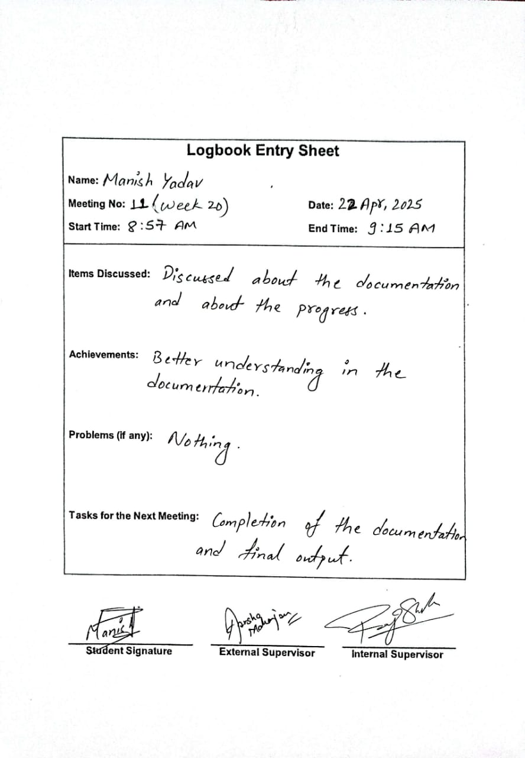

Figure 13 Logbook 11

**Trello**

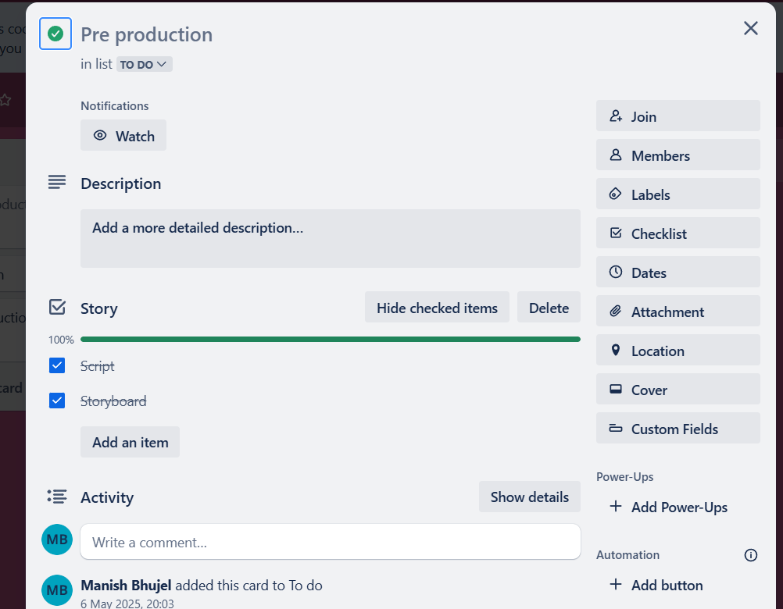

Figure 14 Project Managing 1

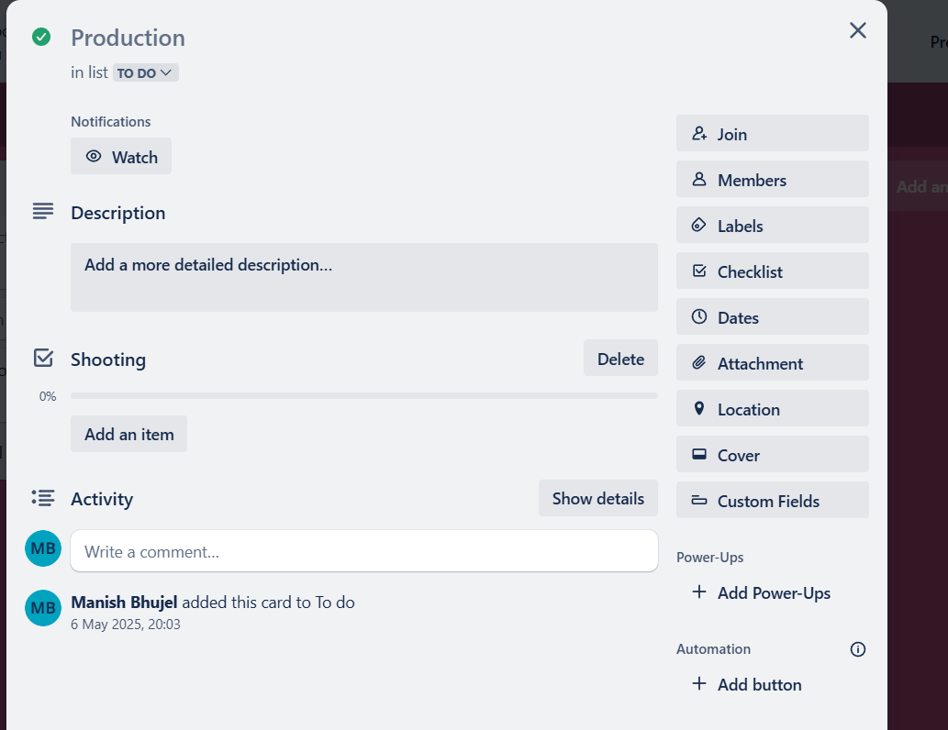

Figure 15 Project managing 2

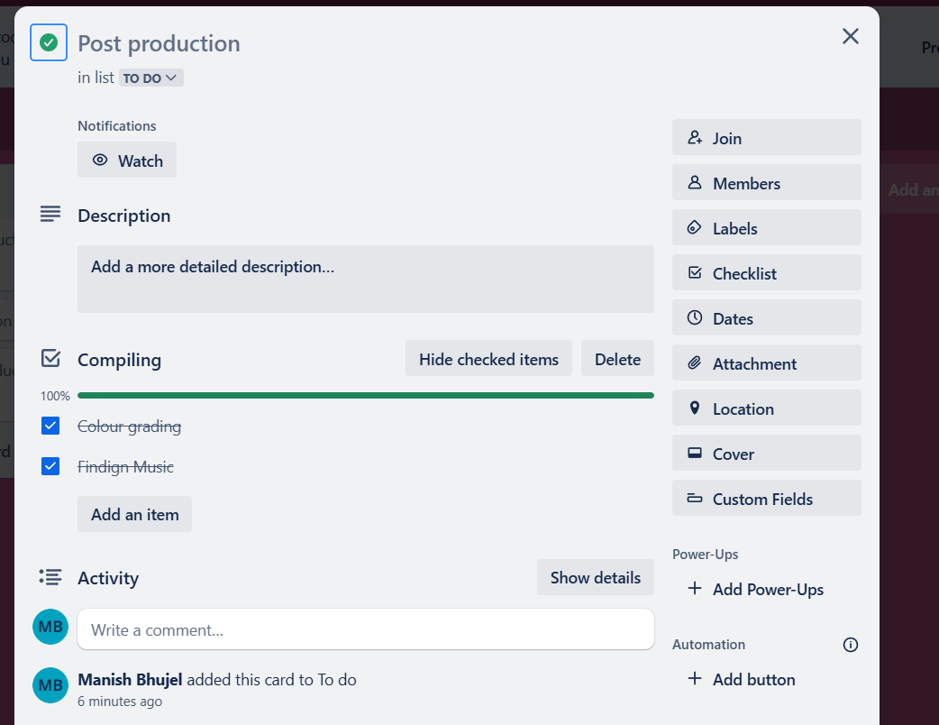

Figure 16 Project Managing 3